ELEC 2FH4 – Topics + HW Reference

In Class Topics Cross Referenced w/ Textbook

Vector Algebra
- Scalars and Vectors (1.3 - p. 4)
- Unit Vector (1.4 - p. 5)
- Vector Addition and Subtraction (1.5 - p. 6)
- Position and Distance Vectors (1.6 - p. 7)
- Vector Multiplication (1.7 - p. 11)
- Components of a Vector (1.8 – p. 16)

Coordinate Systems
- Vector triple product (1.7 – p. 11)
- Components of a vector (1.8 – p. 16)
- Circular cylindrical coordinates (2.3 – p. 32)
- Spherical Coordinates (2.4 – p. 35)
- Constant-Coordinate Surfaces (2.5 – p. 44)

Vector Calculus
- Differential Length, Area, and Volume (3.2 – p. 59)
- Line, Surface, and Volume Integrals (3.3 – p. 66)
- Fields, Scalar and Vector
- Del Operator (3.4 – p. 69)
- Gradient of a Scalar (3.5 – p. 71)
- Divergence of a Vector (3.6 – p. 75)
- Divergence Theorem (3.6 – p. 78)
- Curl of a Vector and Stokes’s Theorem (3.7 – p. 82)
- Classification of Vector Fields (3.9 – p. 92)
- Laplacian (3.8 – p. 90)
- Divergence and Curl with scaling factors
- Chapter Review

Electrostatics
- Coulomb’s Law and Field Intensity (4.2 – p. 112)
- Electric Fields Due to Continuous Charge Distribution (4.3 – p. 119)
- Electric Flux Density (4.4 – p. 130)
- Gauss’ Law—Maxwell’s Equation (4.5 – p. 132)
- Applications of Gauss’ Law (4.6 – p. 134)
- Electric Potential (4.7 – p. 141)
- Relationship between E and V—Maxwell’s Equation (4.8 – p. 147)
- An Electric Dipole and Flux Lines (4.9 – p. 150)
- Energy Density in Electrostatic Fields (4.10 – p. 154)
- Convection and Conduction Currents (5.3 – p. 178)
- Conductors (5.4 – p. 181)
- Conductors (5.4 – p. 181)
- Polarization in Dielectrics (5.5 – p. 187)
- Dielectric Constant and Strength (5.6 – p. 190)
- Continuity Equation and Relaxation Time (5.8 – p. 196)
- Boundary Conditions (5.9 – p. 198)
- Poisson’s and Laplace’s Equations (6.2 – p. 225)
- Solving Poisson’s or Laplace’s Equation (6.4 – p. 228)
- Resistance and Capacitance (6.5 – p. 249)
- Method of Images (6.6 – p. 266)

Magnetostatics
- Biot–Savart’s Law (7.2 – p. 298)
- Ampère’s Circuit Law—Maxwell’s Equation (7.3 – p. 309)
- Applications of Ampère’s Law (7.4 – p. 309)
- Magnetic Flux Density—Maxwell’s Equation (7.5 – p. 317)
- Maxwell’s Equations for Static Fields (7.6 – p. 319)
- Magnetic Scalar and Vector Potentials (7.7 – p. 320
- Forces due to Magnetic Fields (8.2 – p. 349)
- Magnetic Torque and Moment (8.3 – p. 361) <----- we’re here at the moment

Textbook HW

Chapter 1
- Practice Exercises: 1.2, 1.4, 1.5
- End-of-Chapter Problems: 1.3, 1.4, 1.6, 1.8, 1.11, 1.13, 1.19

Chapter 2
- End-of-Chapter Problems: 2.1 – 2.6, 2.11, 2.14, 2.15, 2.17, 2.18, 2.29

Chapter 3
- End-of-Chapter Problems: 3.1 – 3.6, 3.11, 3.16, 3.17, 3.18, 3.20, 3.27 – 3.29, 3.31 – 3.36, 3.40 – 3.43, 3.45 – 3.48, 3.51, 3.52, 3.54, 3.55 – 3.60
- Problem 3.36 is especially important

Chapter 4
- End-of-Chapter Problems: 4.1, 4.2, 4.3, 4.5 – 4.7
- Sections 4-5 to 4-8

Chapter 5
- End-of-Chapter Problems: 5.1–5.5, 5.8, 5.14–5.19, 5.30, 5.31, 5.38–5.42

Chapter 6
- End-of-Chapter Problems: 6.1, 6.2, 6.4, 6.7, 6.11, 6.13–6.16, 6.29–6.31, 6.66

Chapter 7
- End-of-Chapter Problems: 7.1–7.4, 7.6, 7.7, 7.10, 7.16, 7.17, 7.34, 7.37, 7.40, 7.41

Chapter 8
- End-of-Chapter Problems: 8.1–8.9, 8.18–8.21, 8.24–8.26, 8.30–8.34, 8.42–8.46, 8.50, 8.51

Chapter 9
- oopsies, we don’t cover this

Chapter 10
- oopsies, we don’t cover this

Textbook Chapter Summaries

Chapter 1
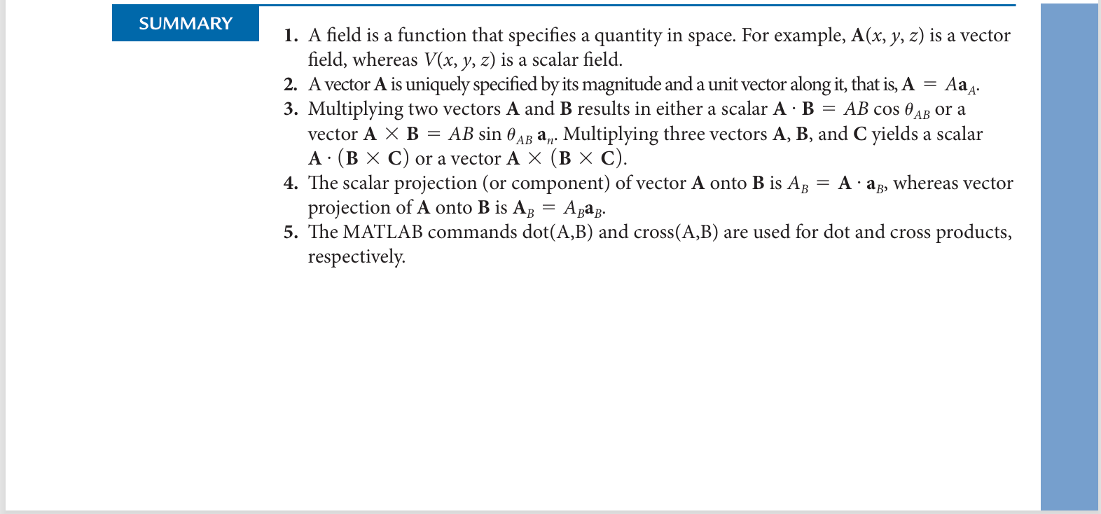

Chapter 2
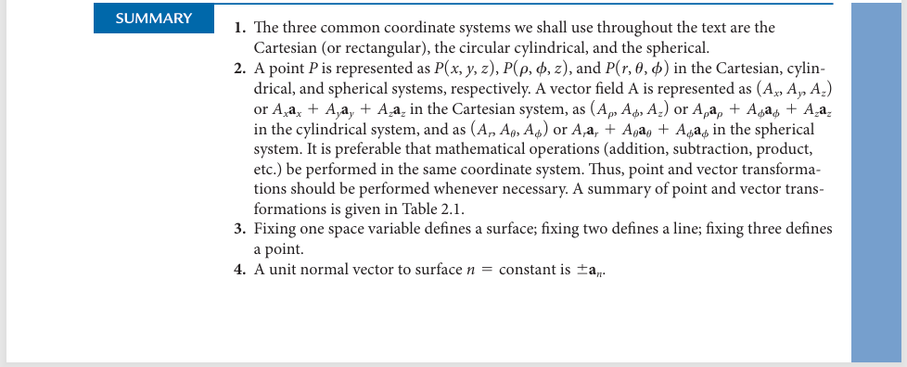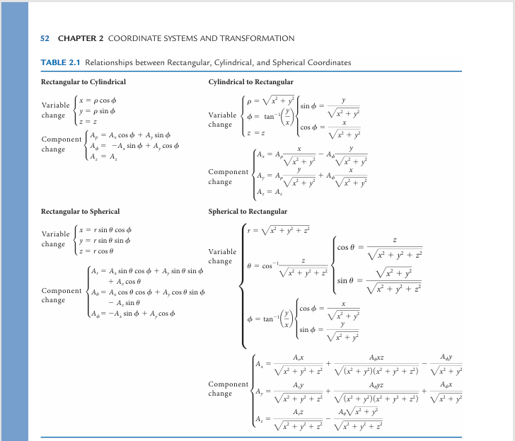

Chapter 3
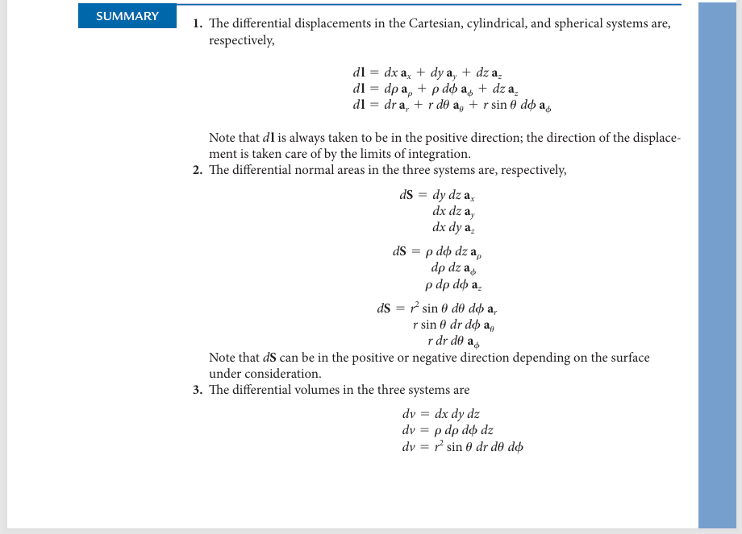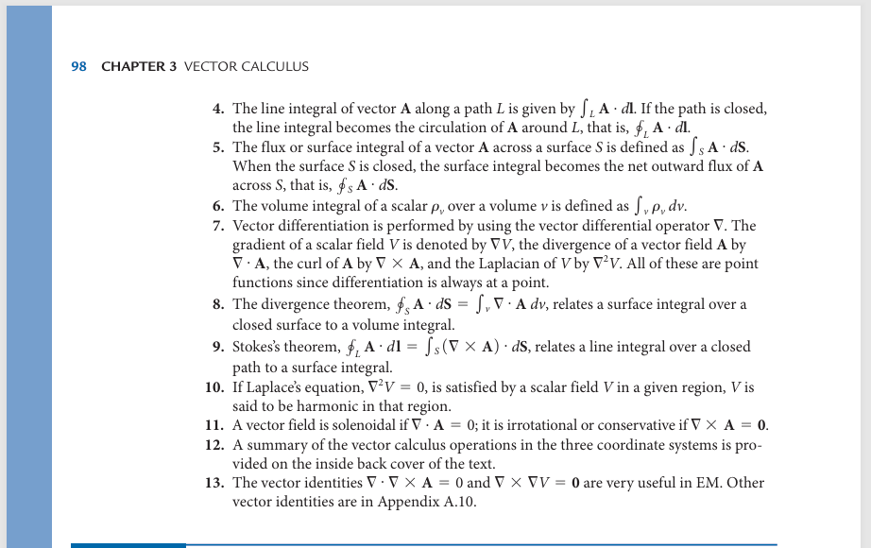

Chapter 4
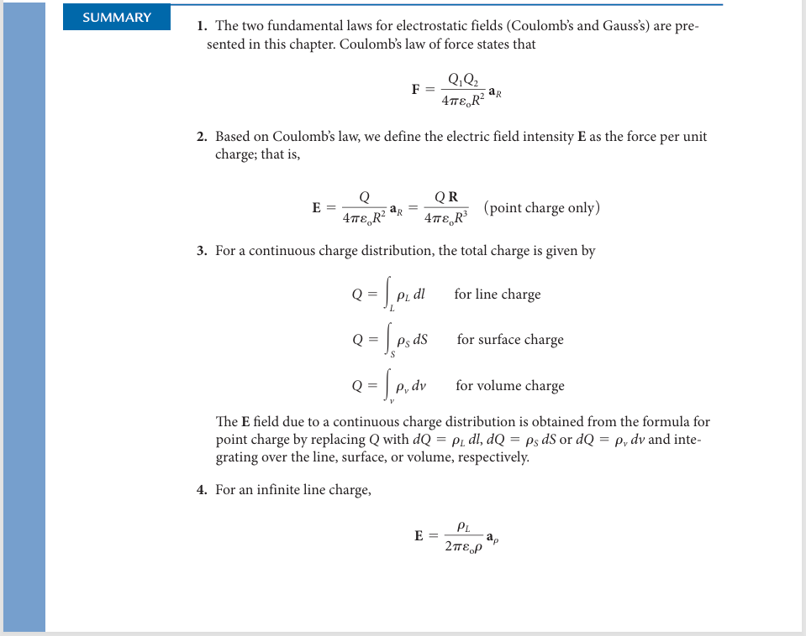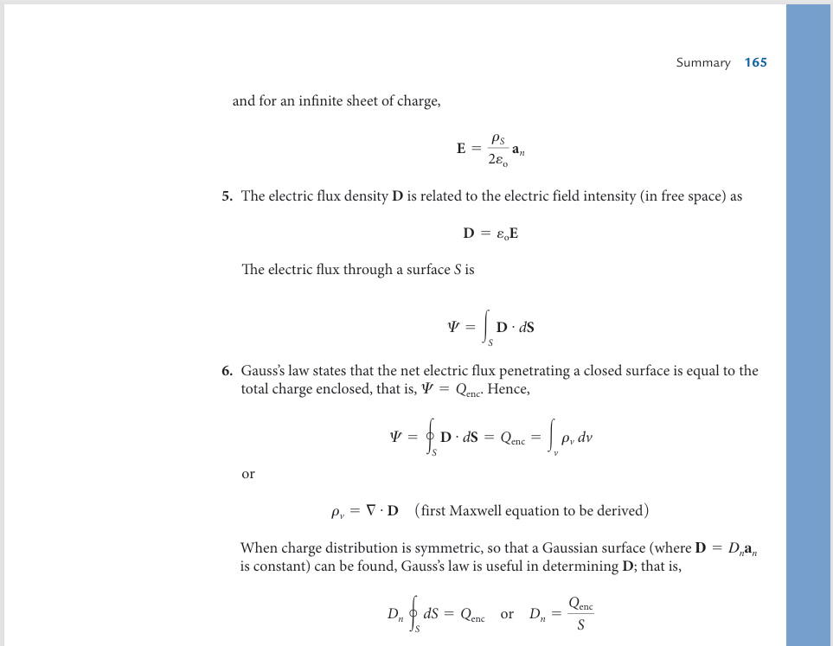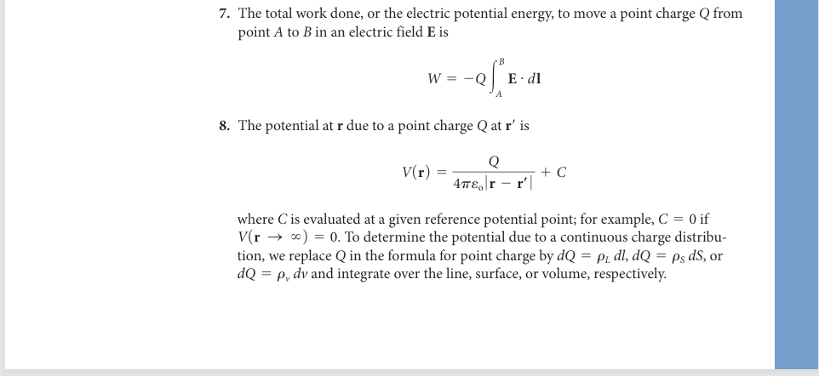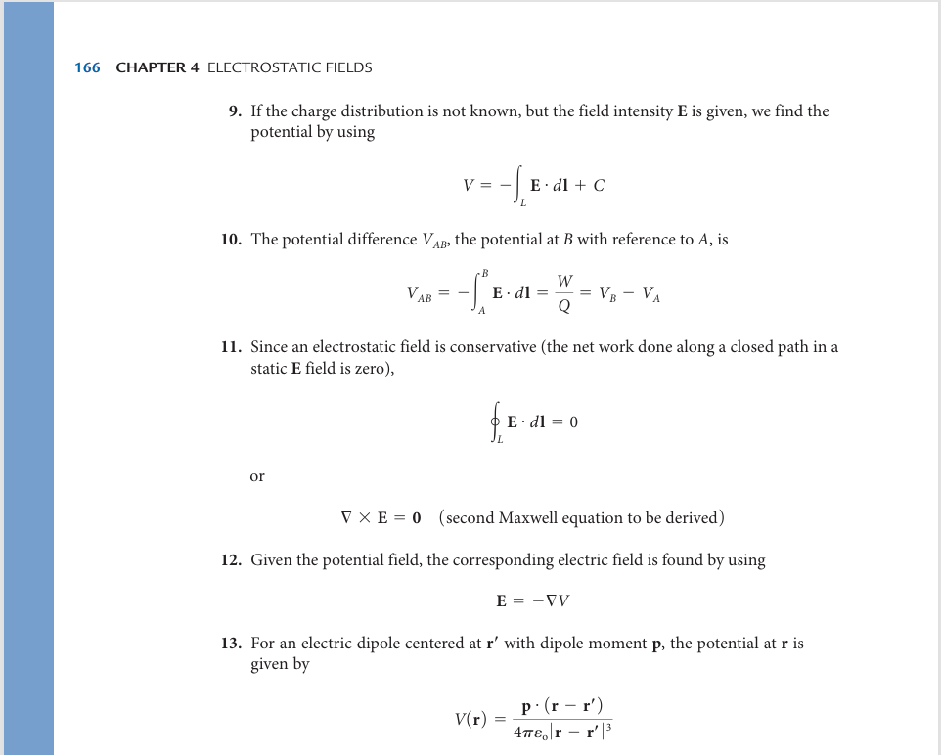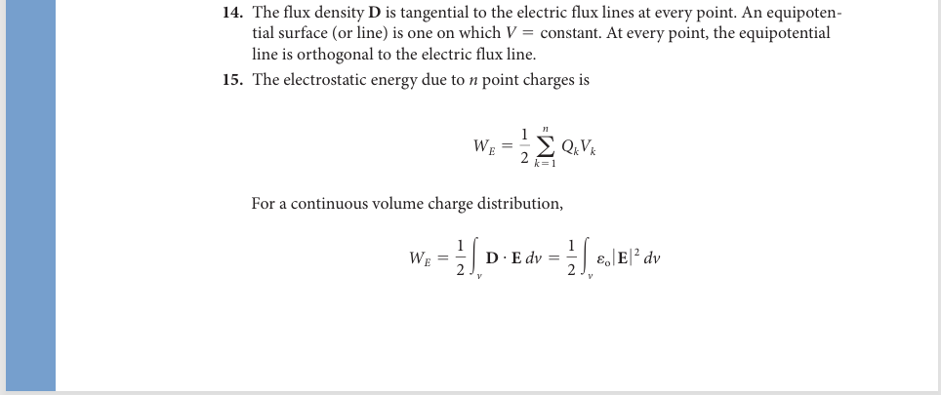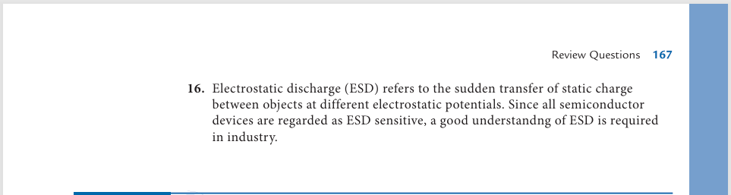

Chapter 5
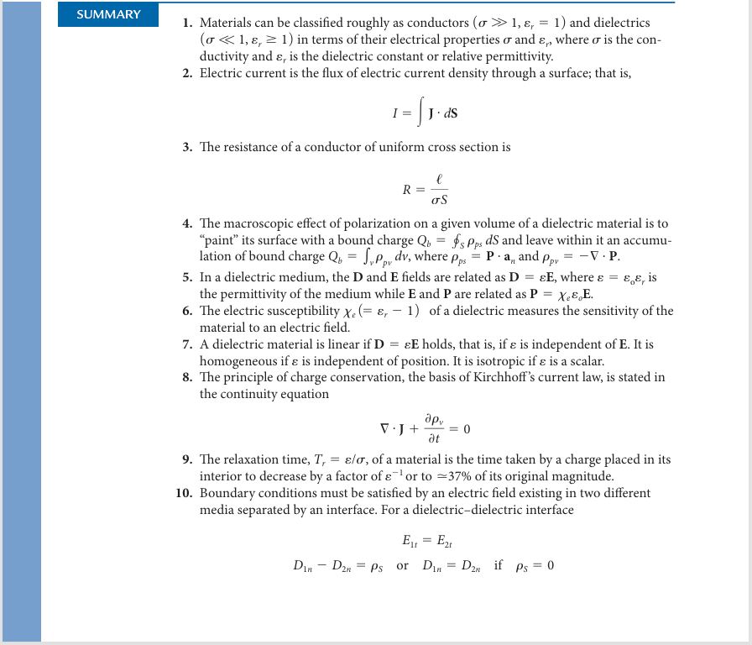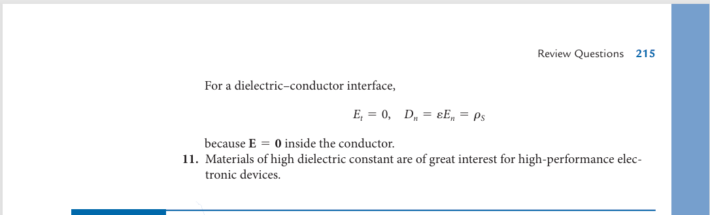

Chapter 6

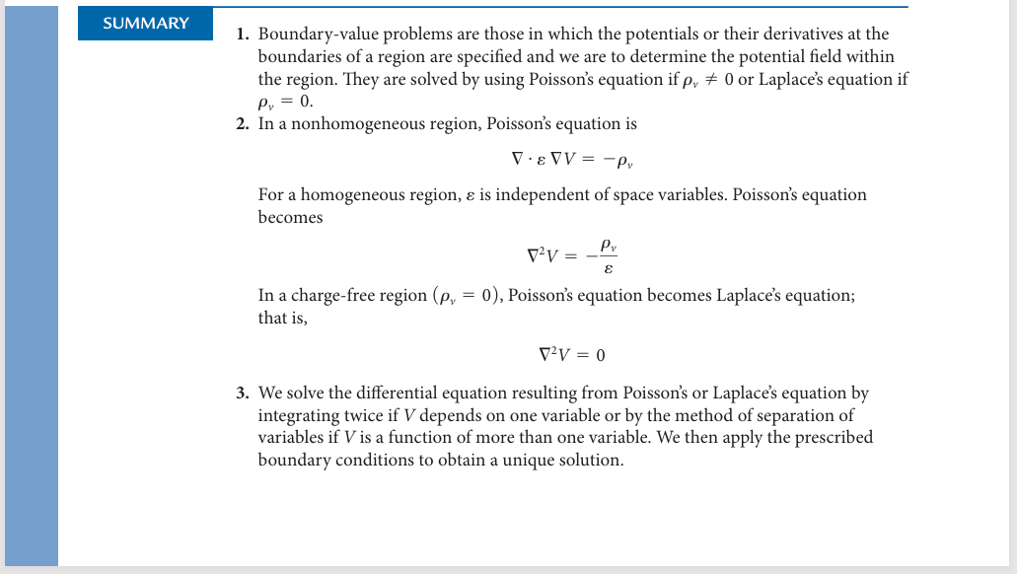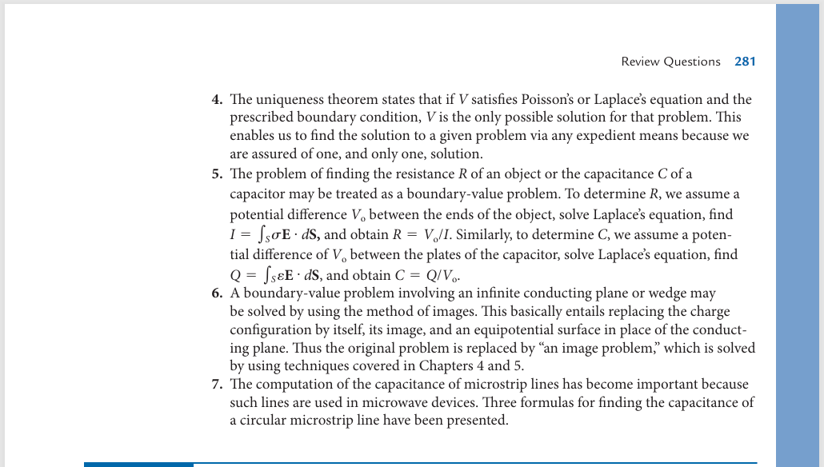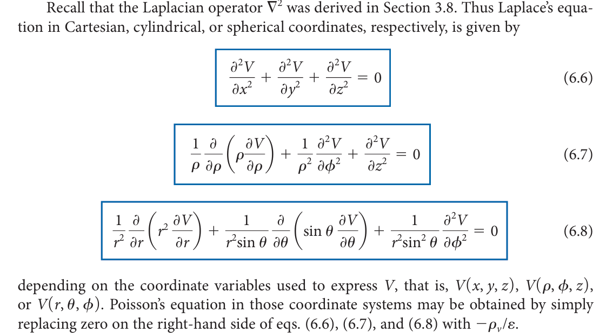

Chapter 7
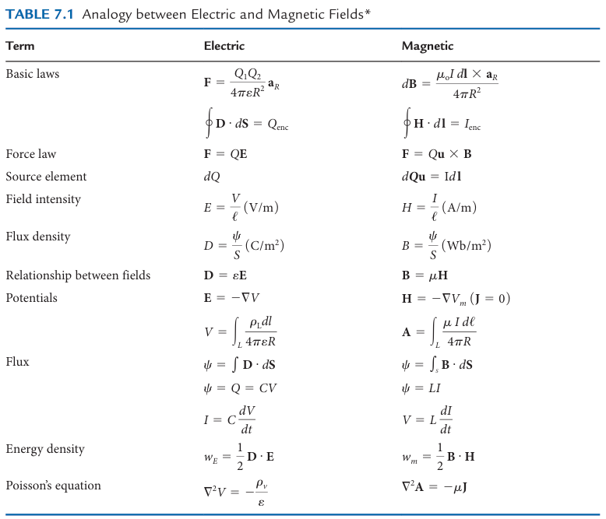
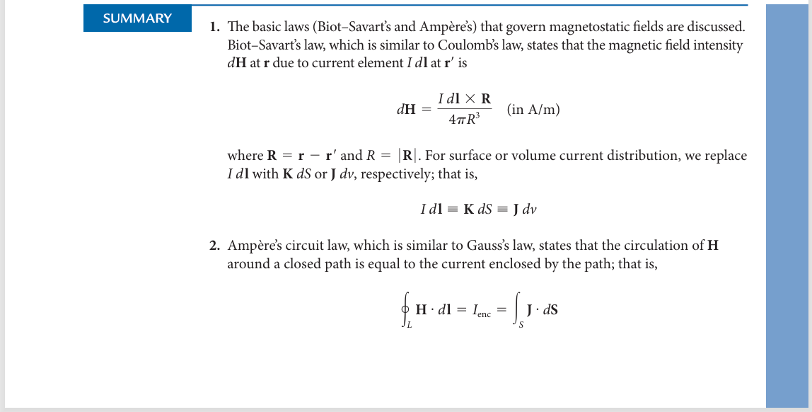
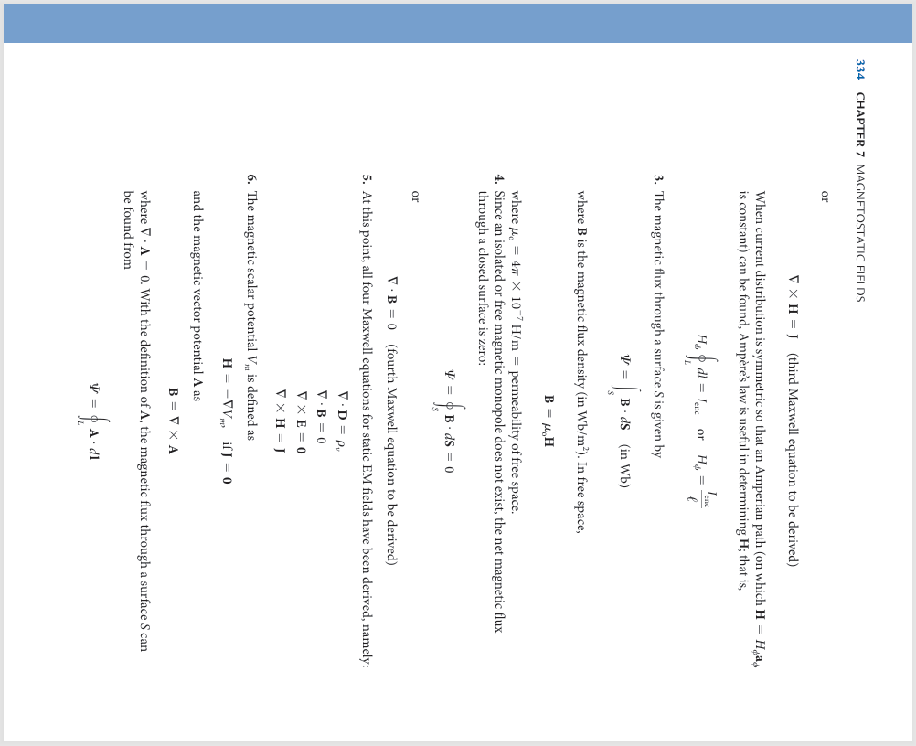
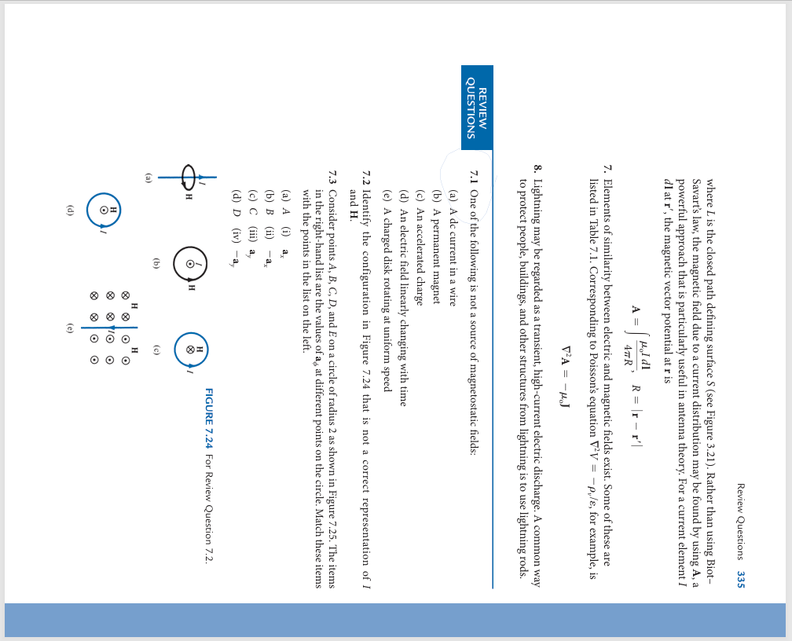
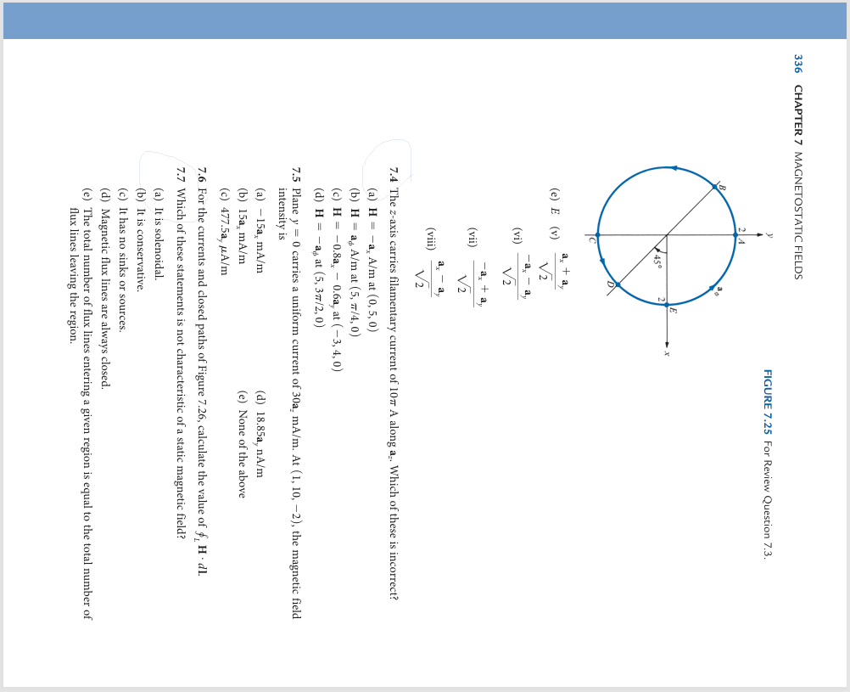
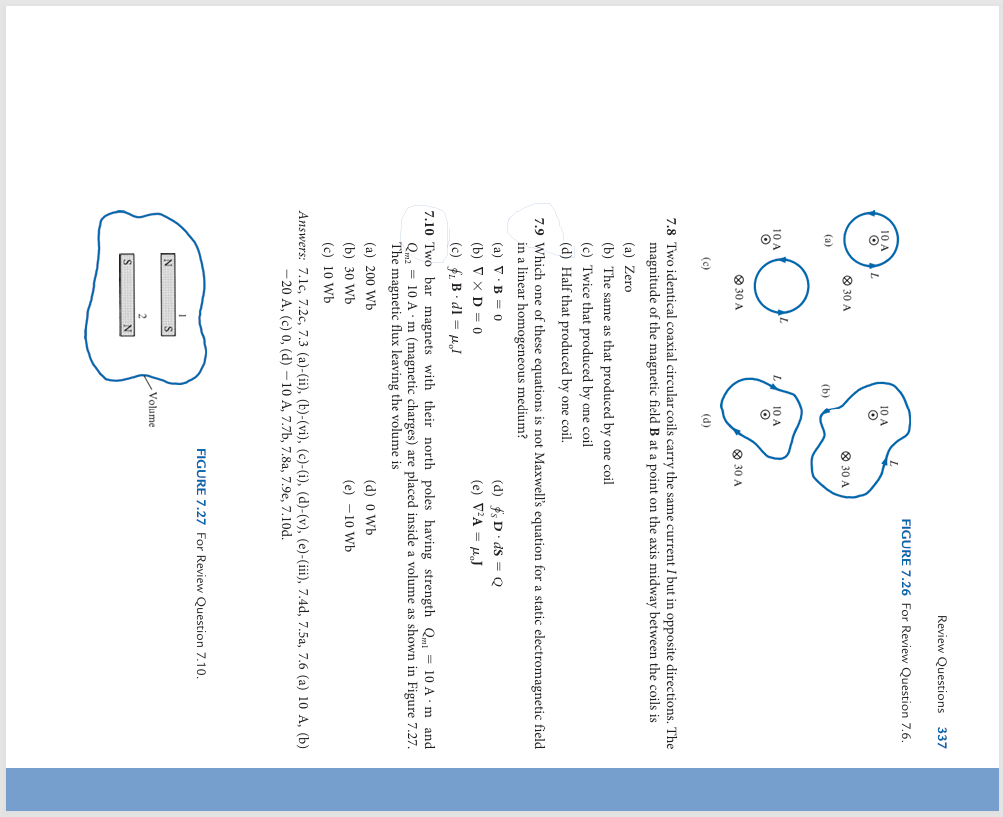

Chapter 8
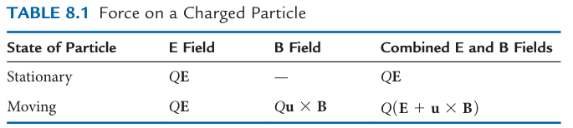
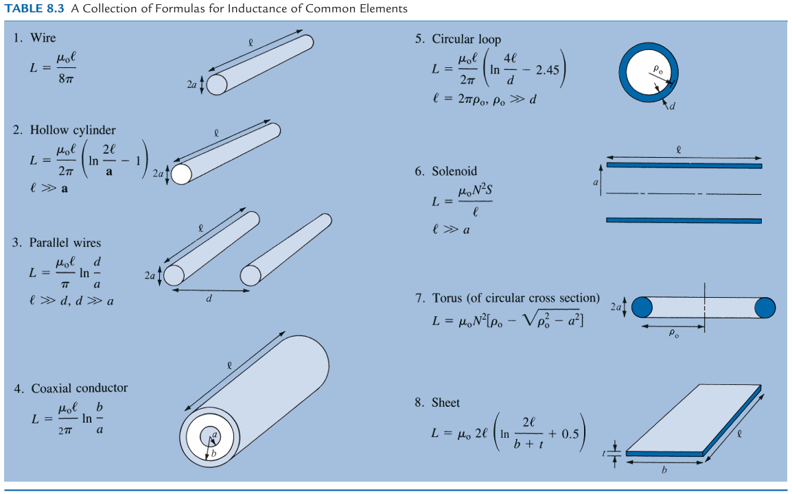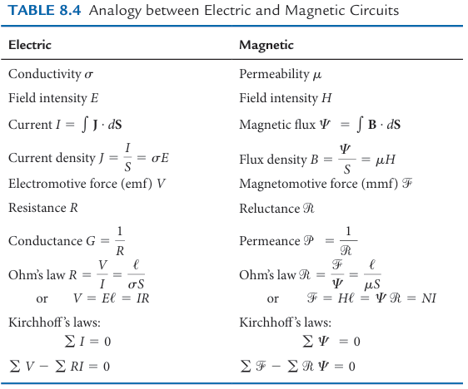
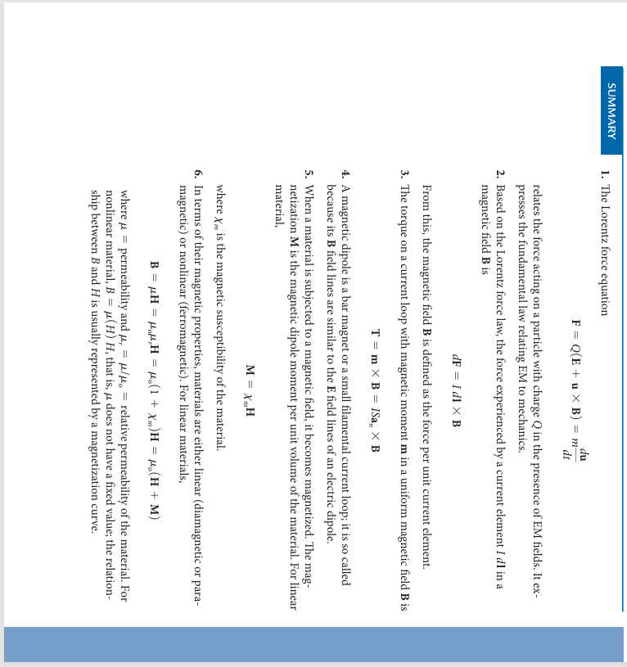
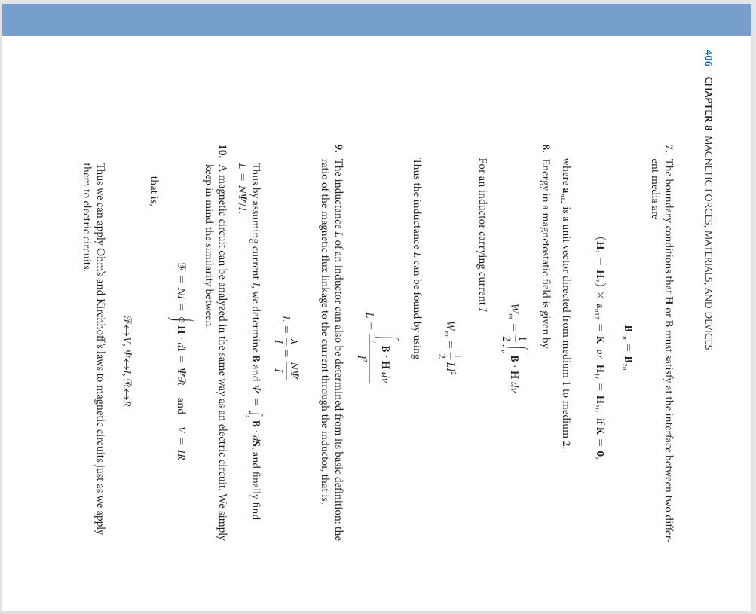
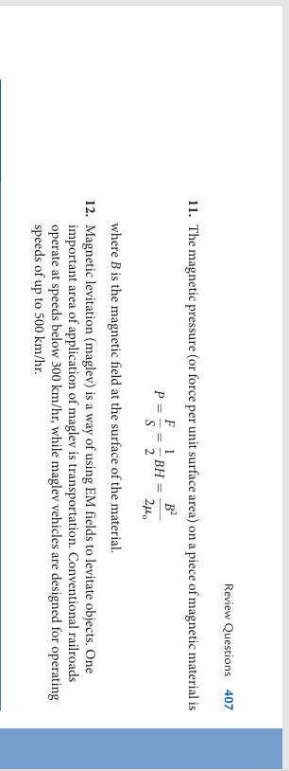

Chapter 9
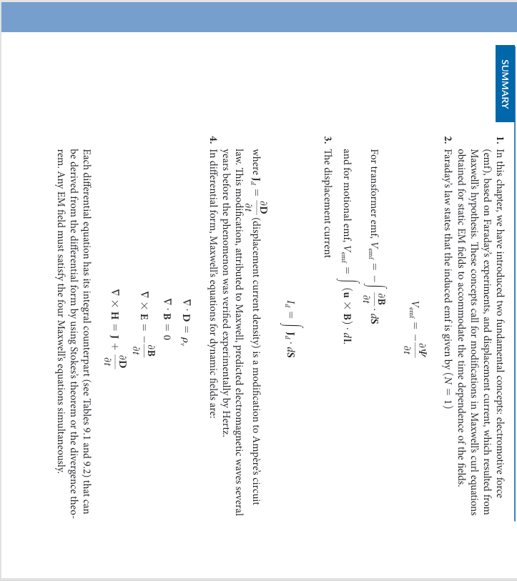
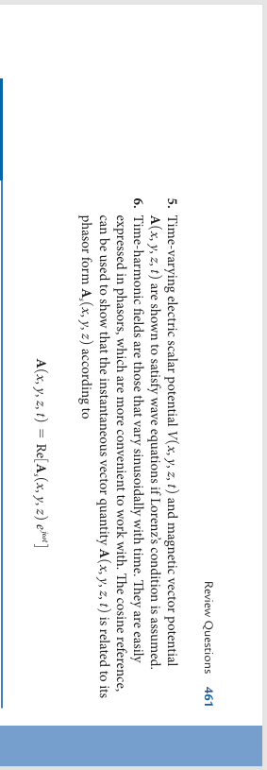

Chapter 10
